CSA0311 - DATA STRUCTURES
OUTPUT PREDICTION
BY: Monica sentamil K (192524315)
2nd Question 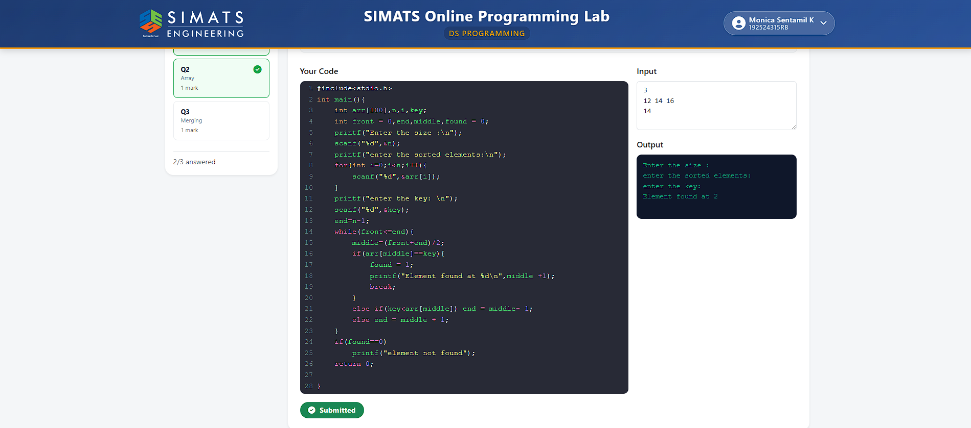
3rd Question:
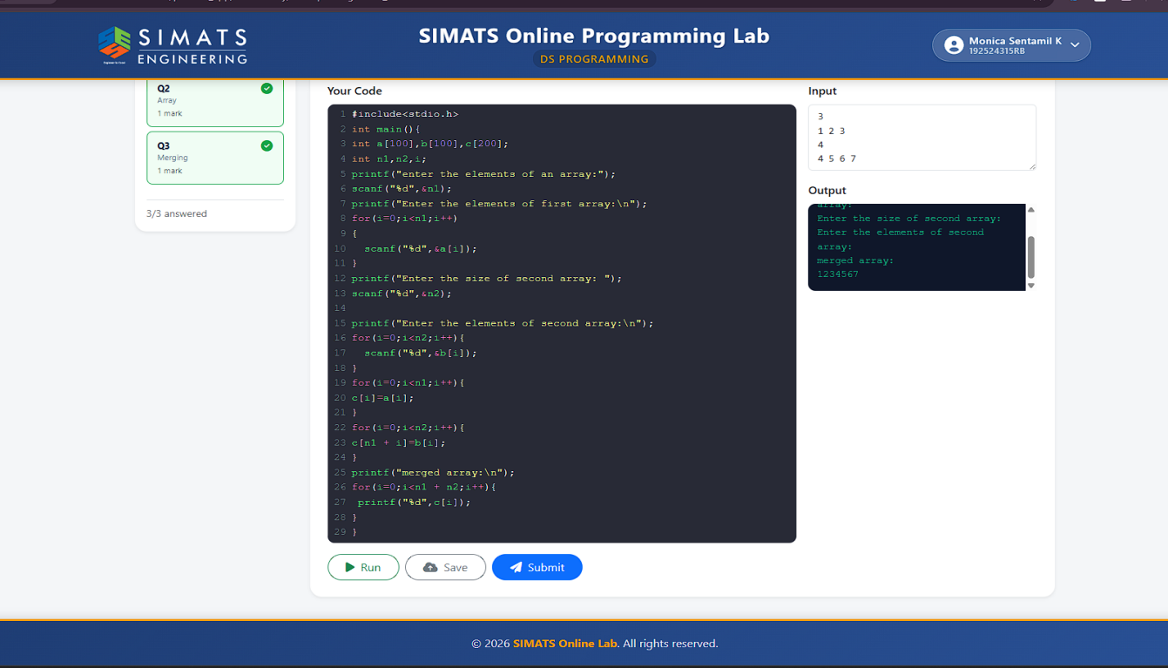
1stQuestion :